From : Mr. Ozdil, College Guidance Counselor

To : The parent(s)/guardian(s)

RE : Credit By Exam Information Letter for High School Students

Dear Parent(s)/Guardian(s),
Welcome to the Credit by Examination testing process. Credit by Exam provides a way for students to receive credit and advance.
Credit by Examination without Prior Instruction
High school students who wish to earn credit for a course in which they have had no prior formal instruction may test through credit by exam. This is option must be approved by the campus Principal or the school counselor. Students must demonstrate 90% or higher mastery on the exam in order to earn credit. Students are encouraged to review the course objectives and exam specifications.

Credit by Examination without Prior Instruction
Students under certain circumstances may be able to take Credit by Exam for a course in which they have had prior instruction but did not receive credit. . This option generally applies to students who have not earned credit due to extenuating circumstances such as a family move, illness, etc. or to students who failed the course 69 or below. Students are encouraged to review the course objectives.
Students must demonstrate 70% or higher mastery on the tests. Applications are available from the school counselor. Contact via email: cozdil@harmonytx.org.
How to Apply
Application must be made through the school counselor. Students must complete applications by May 31st.
Students who apply for Credit By Examination are strongly encouraged to begin preparing for the exams as soon as possible. Students need to apply for Credit By Examination as soon as they are aware of the need or desire to test because they may need to know the results in time to make other plans to earn the credit if they are not successful on the Credit By Exam.
Test Dates:
TEST DATE | Application due by 4:00 pm
Monday, July 1, 2013  Tuesday, July 2, 2013 | Friday, May 31, 2013

Costs:

 | Costs Per ½ Credit Exam | Full Year Credit Exam
Grades 9-12 | $25 | $50

Exams:

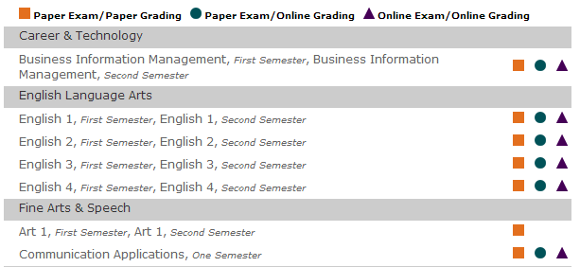

If you have any question, please feel free to contact me.

E-mail: cozdil@harmonytx.org
Phone: 972-642-9911

John Ozdil
College Guidance Counselor
Physics/Engineering Teacher

